|  |  |  |
| --- | --- | --- |
|  |  | Python progamming  By Rohit Kushwaha |

Python is a popular programming language. It was created by Guido van Rossum, and released in 1991.

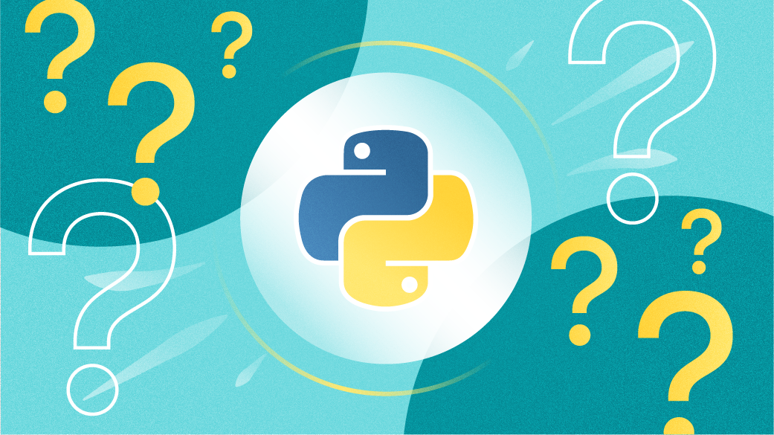

**What is Programming and Python?**

Programming is a way for us to tell computers what to do . The computer is a very dumb machine and it only does what we tell it to do . Hence we learn to program and tell computers to what we are very slow at rate - computation. If I ask you to calculate 5+6, you will immediately say 11. How about 23453453 X 56456?  
You will start searching for a calculator or jump to a new tab to calculate the same. This 100 days of code series will help you learn Python from starting to the end. We will start from 0 and by the time we end this course, I promise you will be a Job ready Python developer!

**What is Python?**

* Python is a dynamically typed, general-purpose programming language that supports an object-oriented programming approach as well as a functional programming approach.
* Python is an interpreted (meaning, source code of a Python program is converted into bytecode that is then executed by the Python virtual machine) and high-level programming language.
* It was created by Guido Van Rossum in 1989.

**Features of Python**

* Python is simple and easy to understand.
* It is Interpreted and platform-independent which makes debugging very easy.
* Python is an open-source programming language.
* Python provides very big library support. Some popular libraries include NumPy, Tensorflow, Selenium, OpenCV, etc.
* It is possible to integrate other programming languages within Python.

**What is Python used for**

* Python is used in Data Visualization to create plots and graphical representations.
* Python helps in Data Analytics to analyze and understand raw data for insights and trends.
* It is used in AI and Machine Learning to simulate human behavior and to learn from past data without hard coding.
* It is used to create web applications.
* It can be used to work with databases.
* It is used in business and accounting to perform complex mathematical operations along with quantitative and qualitative analysis.

**Modules and pip in Python!**

Module is like a code library which can be used to borrow code written by somebody else in our python program. There are two types of modules in python:

1. Built in Modules - These modules are ready to import and use and ships with the python interpreter. there is no need to install such modules explicitly.
2. External Modules - These modules are imported from a third party file or can be installed using a package manager like pip or conda. Since this code is written by someone else, we can install different versions of a same module with time.

**The pip command**

It can be used as a package manager [pip](https://pip.pypa.io/en/stable/) to install a python module. Lets install a module called pandas using the following command

pip install pandas

**Python Comments:**

A comment is a part of the coding file that the programmer does not want to execute, rather the programmer uses it to either explain a block of code or to avoid the execution of a specific part of code while testing.

**Single-Line comments:**

To write a comment just add a ‘#’ at the start of the line.

### Example 1

#This is a 'Single-Line Comment'

print("This is a print statement.")

**Output:**

This is a print statement.

**Example 2**

Print(“Hello World !!!”) # printing Hello world

**Output :**

Hello World ! ! !

**Example 3:**

Print(“Python Program”)

#print(“Python program”)

**Output:**

Python program

**Mulit-Line Comments:**

To write multi line comments you can use ‘#’ at each line or you can use the multiline string:

**Example1:** The use of ‘#’

#It will execute a block of code if a specified condition is true.

#If the condition is false then it will execute another block of code.

p = 7

if (p > 5):

print("p is greater than 5.")

else:

print("p is not greater than 5.")

**Output:**

p is greater than 5.

**Example 2 :**  The use of multiline string.

"""This is an if-else statement.

It will execute a block of code if a specified condition is true.

If the condition is false then it will execute another block of code."""

p = 7

if (p > 5):

print("p is greater than 5.")

else:

print("p is not greater than 5.")

**Escape Sequence characters**

To insert characters that cannot directly used in a string, we use an escape sequence character.

An escape sequence character is a backlash \ followed by the character you want to insert.

An example of a character that cannot be directly used in a string is a double quote inside a string that is surrounded by double quotes:

print("This doesnt "execute")

print("This will \" execute")

**More on print statement:**

The syntax of a print statement looks something like this :

print(object(s), sep=separator, end=end, file=file, flush=flush)

**Other parameters of print statement**

* 1. Object(S) : Any object , and as many as you like. Will be converted to string before printed
  2. Sep=’separator’: specify how to separate the objects. If there is more than on Default is ‘ ‘
  3. End=’end’:specify what to print at the end, Default is ‘\n’ (line feed)
  4. File: An object with a write method. Defualt is sys.stdobut parameters 2 to 4 are optional